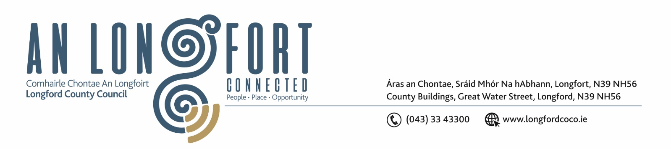

14th November 2018.

Chuig: Gach Ball don Chomhairle.

A Chomhairleoir,

You are requested to attend the Statutory Local Authority Budget Meeting of Longford County Council to be held in the Council Chamber, Aras an Chontae, Longford, on Monday, 26th November 2018 at 4.00 p.m. to transact business as set out on the agenda hereunder.

Mise le meas,
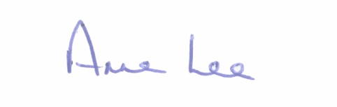

________________
Anne Lee,
Meetings Administrator.

1. Consideration of 2019 Draft Budget - enclosed.

